WEEK 1: DESIGN PATTERNS AND PRINCIPLES

Exercise 1: Implementing the Singleton Pattern
Scenario: You need to ensure that a logging utility class in your application has only one instance throughout the application lifecycle to ensure consistent logging.
//Creation of the Logger calss
class Logger {
private static Logger instance;
private Logger() {
// Initialization of Logger class method
}
public static Logger getInstance() {
if (instance == null) {
instance = new Logger();
}
return instance;
}
public void log(String message) {
System.out.println("Log: " + message);
}
}
class SingletonTest {
public static void main(String[] args) {
Logger logger1 = Logger.getInstance();
Logger logger2 = Logger.getInstance();
logger1.log("This is the first log message.");
logger2.log("This is the second log message.")
if (logger1 == logger2) {
System.out.println("Both logger1 and logger2 are the same instance.");
}
else {
System.out.println("Logger instances are different.");
}
}
}

Output:
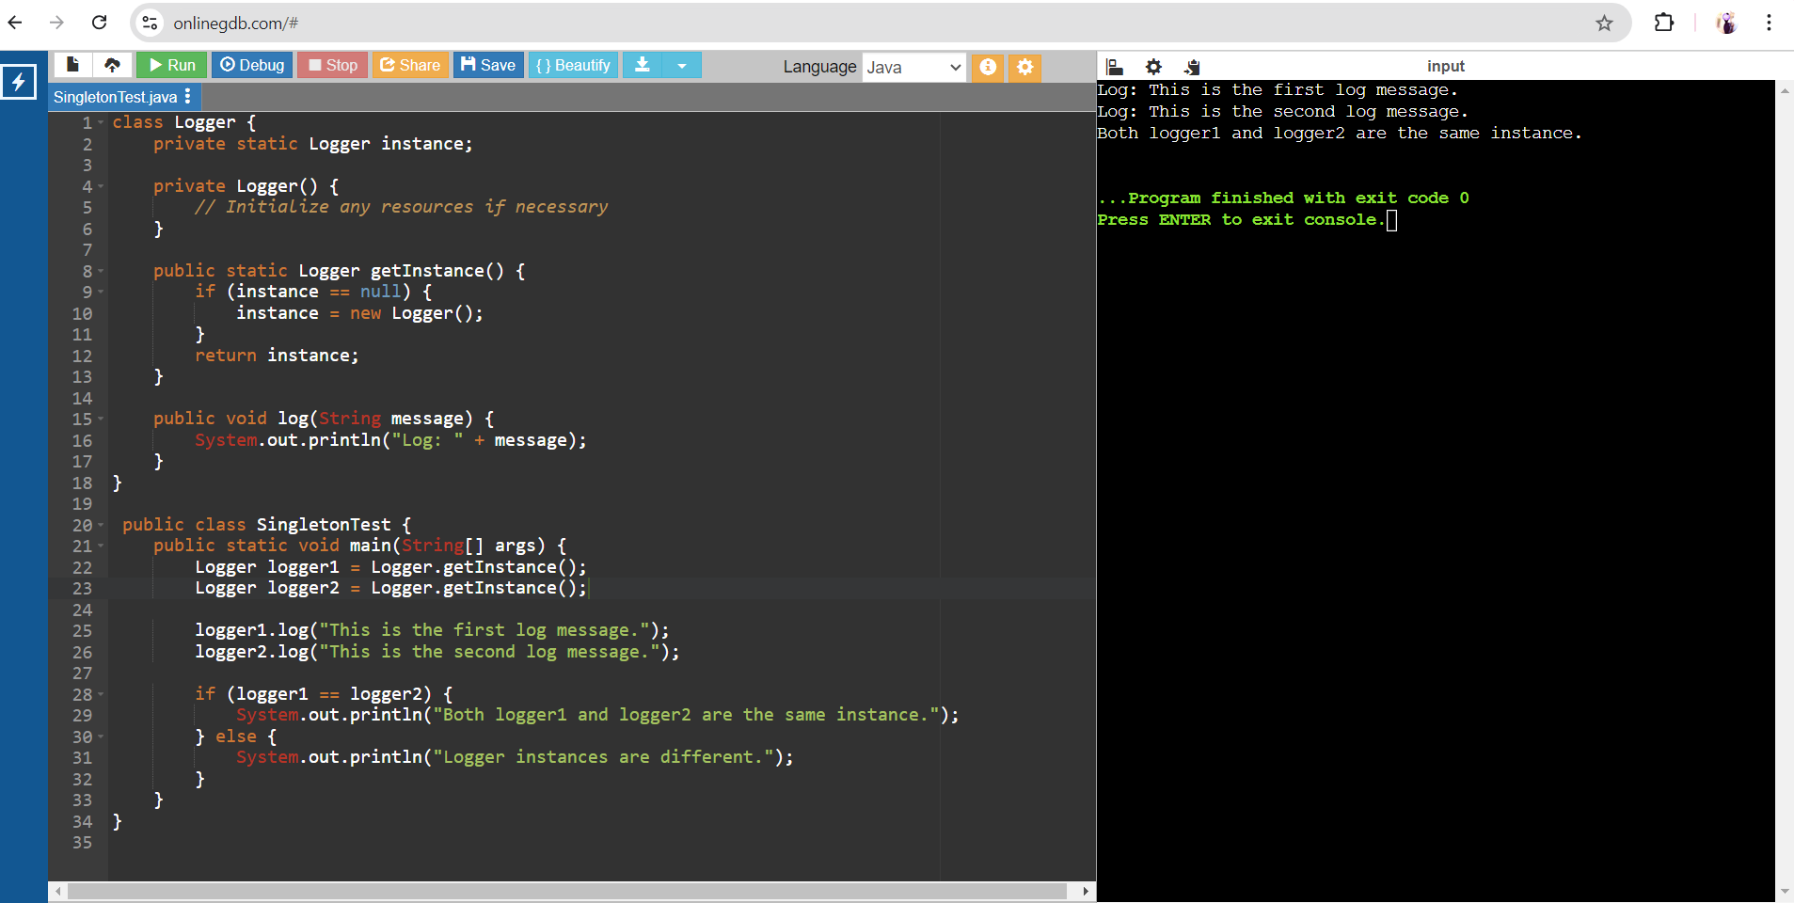

Exercise 2: Implementing the Factory Method Pattern

Scenario: You are developing a document management system that needs to create different types of documents (e.g., Word, PDF, Excel). Use the Factory Method Pattern to achieve this.
interface Document {
void open();
void close();
}
class WordDocument implements Document {
public void open() {
System.out.println("Opening Word document...");
}
public void close() {
System.out.println("Closing Word document...");
}
}
class PdfDocument implements Document {
public void open() {
System.out.println("Opening PDF document...");
}
public void close() {
System.out.println("Closing PDF document...");
}
}
class ExcelDocument implements Document {
public void open() {
System.out.println("Opening Excel document...");
}
public void close() {
System.out.println("Closing Excel document...");
}
}
abstract class DocumentFactory {
public abstract Document create_doc();
}
class WordDocumentFactory extends DocumentFactory {
public Document create_doc() {
return new WordDocument();
}
}
class PdfDocumentFactory extends DocumentFactory {
public Document create_doc() {
return new PdfDocument();
}
}

class ExcelDocumentFactory extends DocumentFactory {
public Document create_doc() {
return new ExcelDocument();
}
}
public class FactoryMethodPatternExample {
public static void main(String[] args) {
DocumentFactory wordFactory = new WordDocumentFactory();
Document wordDocument = wordFactory.create_doc();
wordDocument.open();
wordDocument.close();
DocumentFactory pdfFactory = new PdfDocumentFactory();
Document pdfDocument = pdfFactory.create_doc();
pdfDocument.open();
pdfDocument.close();
DocumentFactory excelFactory = new ExcelDocumentFactory();
Document excelDocument = excelFactory.create_doc();
excelDocument.open();
excelDocument.close();
}
}
Output:
